# Calculating binomial probabilities

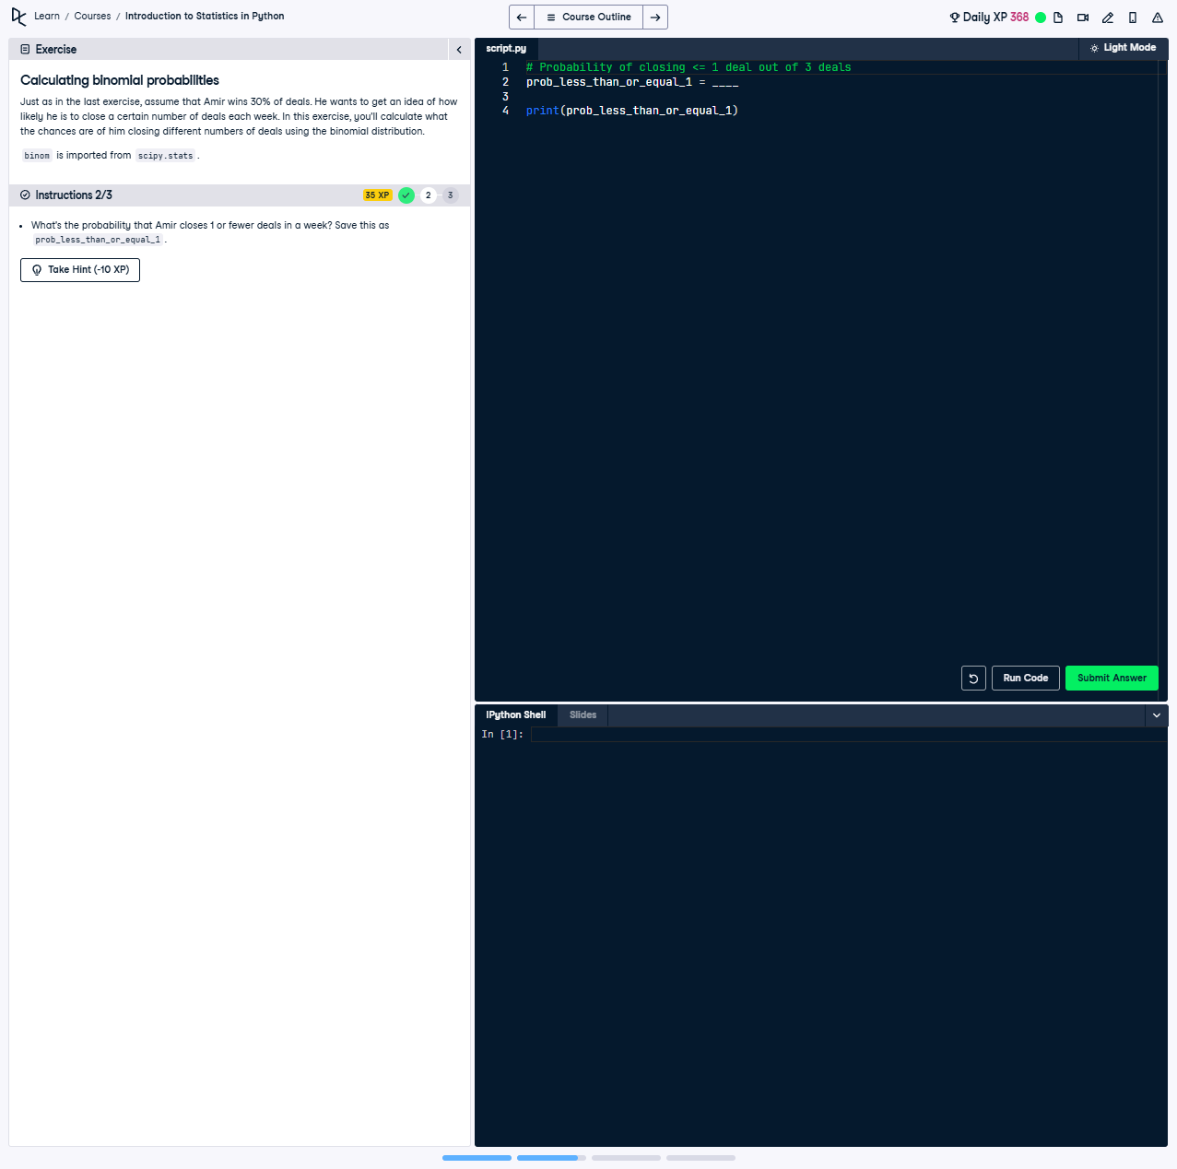

## Question:

What's the probability that Amir closes 1 or fewer deals in a week? Save this as prob_less_than_or_equal_1.

## Explanation of the Question:

This question asks us to calculate the cumulative probability of closing at most 1 deal out of 3 attempts, where the success probability for each attempt is 30%. This involves calculating the sum of probabilities for 0 and 1 successful outcomes.

## Answer:

from scipy.stats import binom  
  
# Use the binom.cdf function to calculate the probability  
prob_less_than_or_equal_1 = binom.cdf(1, 3, 0.3)  
  
print(prob_less_than_or_equal_1)

## Explanation of the Answer:

The solution uses the binom.cdf function from scipy.stats to compute the cumulative distribution function (CDF) of the binomial distribution. This calculates the sum of probabilities of getting 0 or 1 successful outcomes in 3 trials, with a success probability of 0.3 per trial.